**Question One:**

Suppose an expert, given three conditionally independent evidences

|  |  |  |  |
| --- | --- | --- | --- |
| Probability | Hypothesis | | |
| i=1 | i=2 | i=3 |
| P(*Hi*) | 0.25 | 0.40 | 0.35 |
| P(*E1*|*Hi*) | 0.5 | 0.3 | 0.8 |
| P(*E2*|*Hi*) | 0.7 | 0.9 | 0.0 |
| P(*E3*|*Hi*) | 0.9 | 0.6 | 0.7 |

E1, E2 and E3, creates three mutually exclusive and exhaustive hypotheses

H1, H2 and H3, and provides prior probabilities for these hypotheses – p(H1),

p(H2) and p(H3), respectively.

The expert also determines the conditional probabilities of observing each

evidence for all possible hypotheses. The following Table illustrates the prior

and conditional probabilities provided by the expert.

* 1. compute the following

1. P(H*i*|E1) where i=1.
2. P(H*i*|E1E2), P(H*i*|E1E3), P(H*i*|E2E3) where i=2.
3. P(H*i*|E1E2 E3) where i=3.

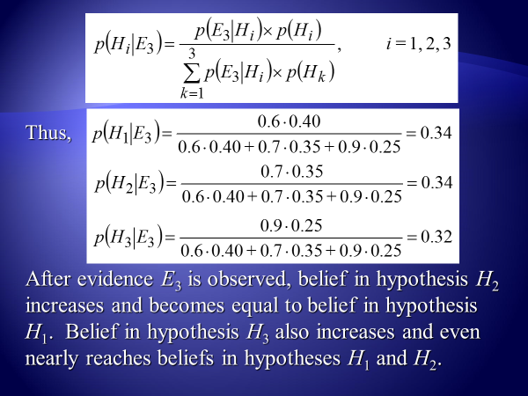

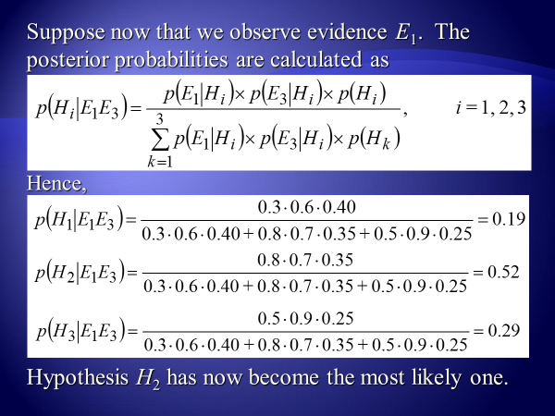

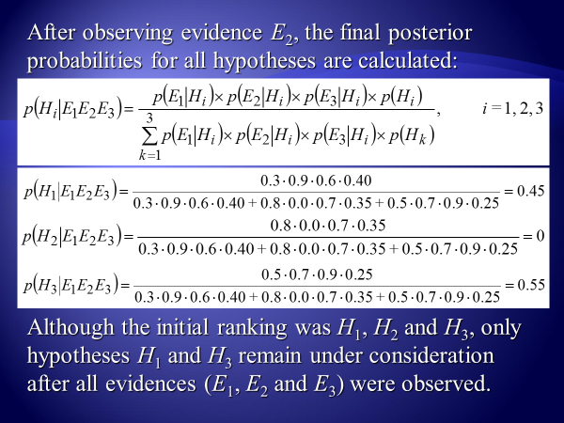

**Question Two:**

1. What is the difference between a crisp set and a fuzzy set?
2. Compute the membership in the set of the following hedges:

*very, extremely, very very, more or less*

for a man has a 0.91 membership in the set of tall men.

1. Suppose we have the following fuzzy sets of tall men and very tall men which define as follow:

*Tall men = {0/180, 0.25/182.5, 0.50/185, 0.75/187.5, 0.5/185, 1/190}*

*Very tall men = {0/180, 0.06/182.5, 0.25/185, 0.56/187.5, 0.5/185, 1/190}*

where each element in the set defines as membership *degree / the actual tall*

Compute the fuzzy set of the following fuzzy sets operations:

Complement of tall men fuzzy set, intersection of tall men fuzzy set and very tall men fuzzy set, union of tall men fuzzy set and very tall men fuzzy set.

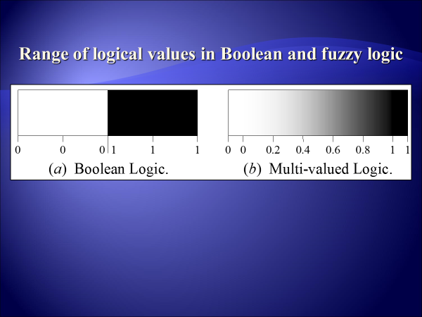

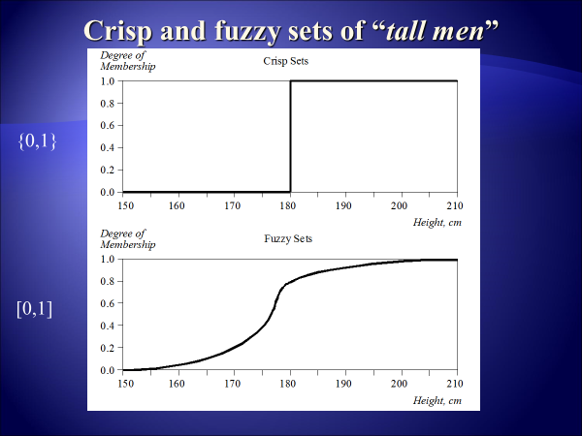

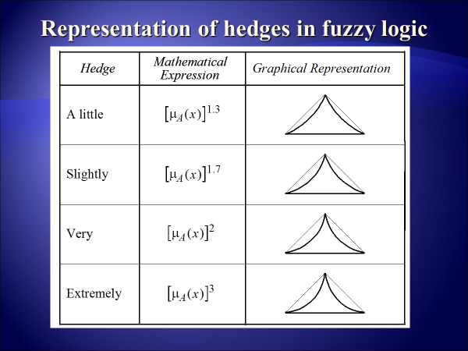

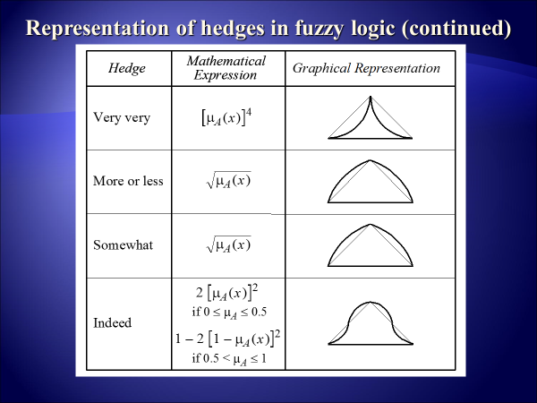







**Question Three:**

1. Explain the main players in the development team of expert systems.
2. Describe the complete structure of a rule-based expert system.
3. Compare between the expert systems with conventional systems and human experts.
4. Let you have the following rules

***X & B & E***

***Y***

### Z

##### Y & D

***L***

### C

***L & M***

***A***

***X***

###### N

And the facts A, B, C, D and E are true, where Z is the goal

Show: how forward chaining and backward chaining works for this simple set of rules?

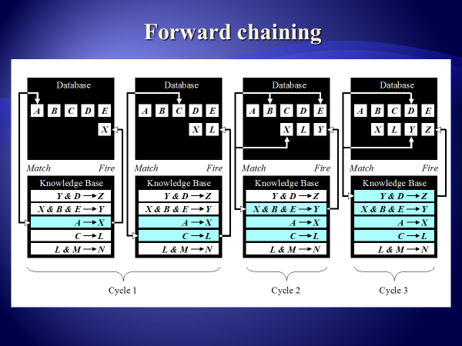

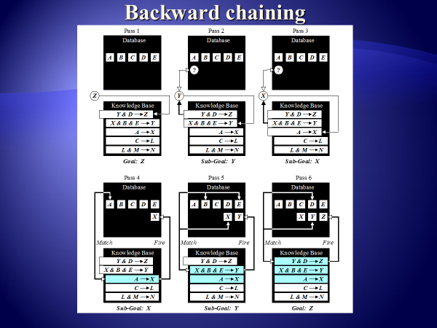

**Question Four:**

Draw the basic structure (Mamdani-style) that simulate the Fuzzy inference(Fuzzification, Rule evaluation, Aggregation of rule consequents, Defuzzification) for the following rules

1. *IF project_funding is adequate*

*OR project_staffing is small*

*THEN risk is low*

1. *IF project_funding is marginal*

*AND project_staffing is large*

*THEN risk is normal*

1. *IF project_funding is inadequate*

*THEN risk is high*

Suppose the ranges of project funding and project staffing between 1 to 100 per cent.

And the crisp input x1=0.35 and y1=0.6

The membership degree for project funding and project staffing and risk as follow:



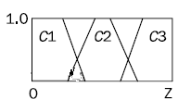

The membership degree for project funding and project staffing

The membership degree for risk

